**Q3.**

**Truth Table:**

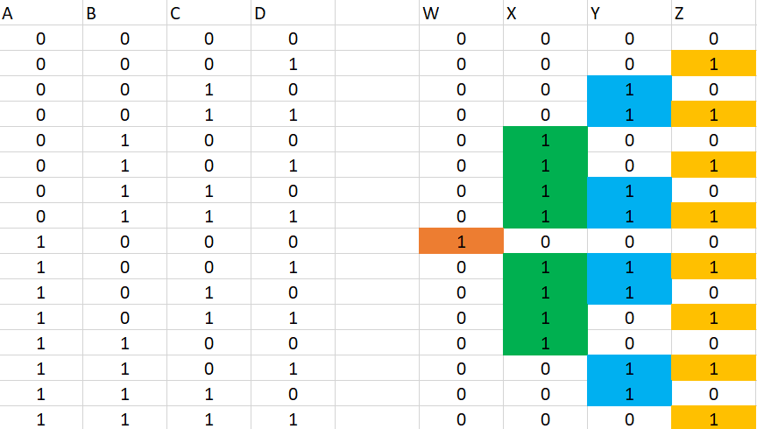 **Input 2’s complement**

Using K-Maps to simplify for W,X,Y,Z:

For W: The only minterm that has a value of 1 is $m_{8}$ which would result in $A*\overline{B}*\overline{C}*\overline{D}$ so that is the equation for W

For the rest: The k-map for 4 variables is as follows:



|  |  |  |  |
| --- | --- | --- | --- |
| $$m_{0}$$ | $$m_{1}$$ | $$m_{3}$$ | $$m_{2}$$ |
| $$m_{4}$$ | $$m_{5}$$ | $$m_{7}$$ | $$m_{6}$$ |
| $$m_{12}$$ | $$m_{13}$$ | $$m_{15}$$ | $$m_{14}$$ |
| $$m_{8}$$ | $$m_{9}$$ | $$m_{11}$$ | $$m_{10}$$ |



For X the K-Map is as follows:



|  |  |  |  |
| --- | --- | --- | --- |
| 0 | $$0$$ | $$0$$ | $$0$$ |
| $$1$$ | $$1$$ | $$1$$ | $$1$$ |
| $$1$$ | $$0$$ | $$0$$ | $$0$$ |
| $$0$$ | $$1$$ | $$1$$ | $$1$$ |

The maximum grouping has been labelled on the figure above. This grouping would result in the equation of X to be:



$$\left(\overline{A}*B\right)+\left(C*A*\overline{B}\right)+\left(D*A* \overline{B}\right)+\left(B* \overline{C}*\overline{D}\right)$$

For Y the K-Map is as follows:



|  |  |  |  |
| --- | --- | --- | --- |
| 0 | $$0$$ | $$1$$ | $$1$$ |
| $$0$$ | $$0$$ | $$1$$ | $$1$$ |
| $$0$$ | $$1$$ | $$0$$ | $$1$$ |
| $$0$$ | $$1$$ | $$0$$ | $$1$$ |

The maximum grouping has been labelled on the figure above. This grouping would result in the equation of Y to be:



$$\left(A*C*\overline{D}\right)+\left(\overline{A}*C\right)+(C*\overline{D})$$

For Z the K-Map is as follows:

|  |  |  |  |
| --- | --- | --- | --- |
| 0 | $$1$$ | $$1$$ | $$0$$ |
| $$0$$ | $$1$$ | $$1$$ | $$0$$ |
| $$0$$ | $$1$$ | $$1$$ | $$0$$ |
| $$0$$ | $$1$$ | $$1$$ | $$0$$ |

The maximum grouping has been labelled on the figure above. This grouping would result in the equation of Z to be: $D$

